Analysis Models

## 1. System Sequence Diagrams

**Figure 1.1 - SSD Authentication**

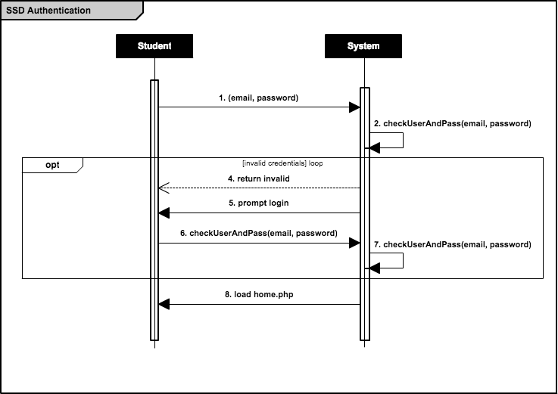

**Figure 1.2.1 - SSD Create Reservation (Booking available)**

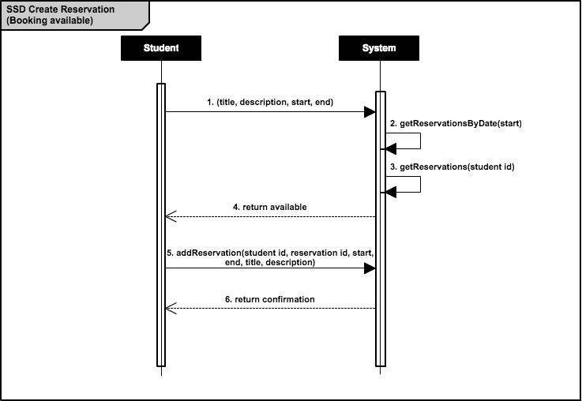

**Figure 1.2.2 - SSD Create Reservation (Booking unavailable)**

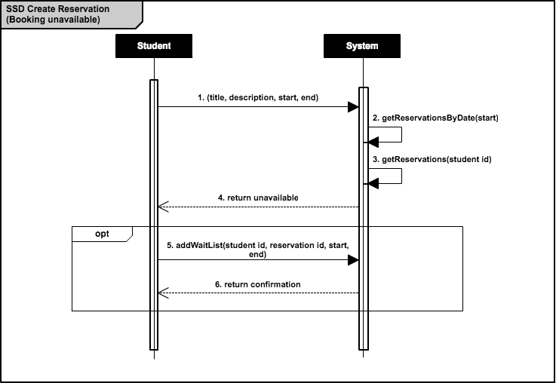

**Figure 1.3 - SSD Cancel Reservation**

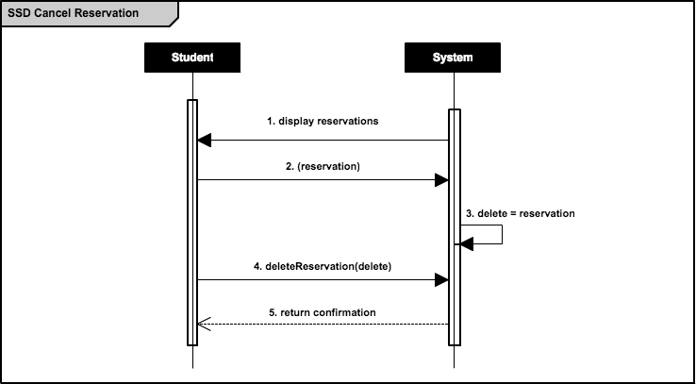

**TEMPORARY Figure 1.4.1 - SSD Modify Reservation (Time)**

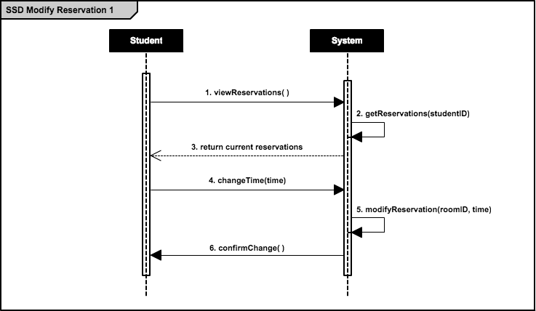

**TEMPORARY Figure 1.4.2 - SSD Modify Reservation (Room)**

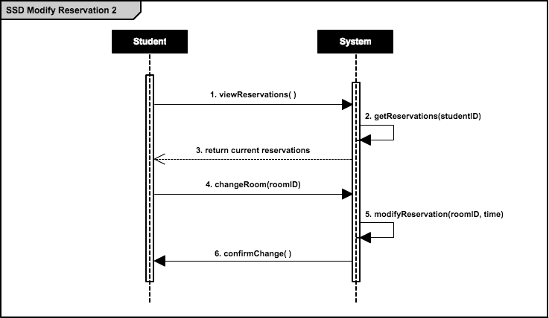

**Figure 1.5 - SSD Change Profile Details**

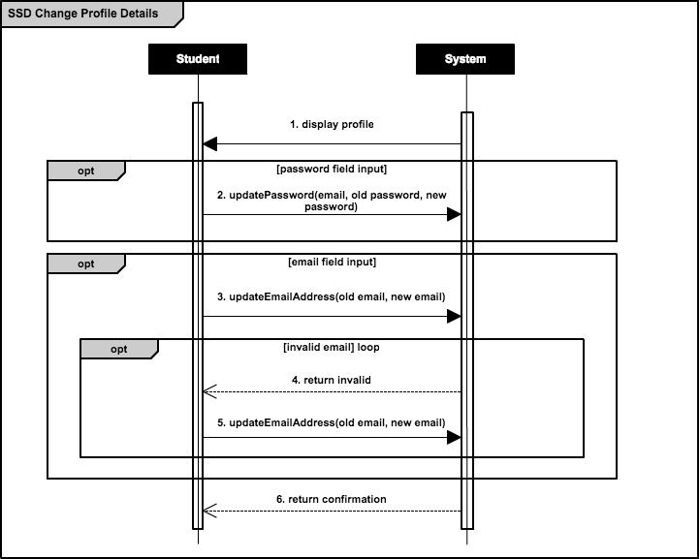

## 2. Operation Contracts

**Figure 2.1 - OC Check Username and Password**

|  |  |
| --- | --- |
| ***Operation Contract 1*** | **Check Username and Password** |
| *Contract* | checkUsernameAndPassword |
| *Operation* | checkUserAndPass(email, password) |
| *Cross-Reference* | Check Username and Password Use Case |
| *Pre-Conditions* | * User has successfully connected to authentication server * User has existing account with valid credentials * User has entered said credentials |
| *Post-Conditions* | * Instance of StudentMapper has been created * Instance of ReservationMapper has been created * Account information has been associated with session |

**Figure 2.2 - OC Add Reservation**

|  |  |
| --- | --- |
| ***Operation Contract 2*** | **Add Reservation** |
| *Contract* | addReservation |
| *Operation* | addReservation(student id, reservation id, start, end, title, description) |
| *Cross-Reference* | Add Reservation Use Case |
| *Pre-Conditions* | * User account has been authenticated (see *Figure 2.1*) * User has selected a valid room, start time, end time, date combination * User has entered a valid title and description * User has less than 3 existing reservations in that week |
| *Post-Conditions* | * Reservation has been associated with database * Student has been associated with reservation |

**Figure 2.3 - OC Add to Waiting List**

|  |  |
| --- | --- |
| ***Operation Contract 3*** | **Add to Waiting List** |
| *Contract* | addToWaitingList |
| *Operation* | addWaitList(student id, reservation id, start, end) |
| *Cross-Reference* | Add to Waiting List Use Case |
| *Pre-Conditions* | * User account has been authenticated (see *Figure 2.1*) * User has selected an invalid room, start time, end time, date combination * User has less than 3 existing reservations in that week |
| *Post-Conditions* | * *reservation.isCreated* has been set to *true* * *reservation* has been associated with *student* |

**Figure 2.4 - OC Update Password**

|  |  |
| --- | --- |
| ***Operation Contract 4*** | **Update Password** |
| *Contract* | updatePassword |
| *Operation* | updatePassword(email, old password, new password) |
| *Cross-Reference* | Update Password Use Case |
| *Pre-Conditions* | * User account has been authenticated (see *Figure 2.1*) * User has entered a valid old password * User has entered a valid new password |
| *Post-Conditions* | * New password is associated with student |

**Figure 2.5 - OC Update Email Address**

|  |  |
| --- | --- |
| ***Operation Contract 5*** | **Update Email Address** |
| *Contract* | updateEmailAddress |
| *Operation* | updateEmailAddress(old email, new email) |
| *Cross-Reference* | Update Email Address Use Case |
| *Pre-Conditions* | * User account has been authenticated (see *Figure 2.1*) * User has entered a valid new email address |
| *Post-Conditions* | * New email address is associated with student |

## 3. Domain Model

**Figure 3 - Domain Model**

